**Porting for Business Customers**

**Process Description**

**Geo & Non-Geo Numbers**

Table of Contents

1.0 Table of Figures 2

2.0 Document Control 3

3.0 Definitions 3

4.0 BAU (Business-as-usual) order handling process 5

4.1 Background 5

4.2 Geo & non-Geo process mis-alignment 6

4.3 A Single CLoA & order handling process (App. R1) 7

4.4 Process description 8

4.5 New CLoA Template (App. R2) 9

4.6 Port Order lead times – Geo & non-Geo alignment 9

5.0 Enhanced Cancellation process 10

6.0 PoV - Pre-Order Validation Process (App. R4) 10

7.0 Appendices 11

7.1 App. R1 – BAU & PoV Order Handling Process Schematics 11

7.2 App. R2 – New CLoA Template 11

7.3 App. R3 - PON Email Templates 11

7.4 App. R4 – PoV Process Description 11

7.5 App. R5 - PoV Process Templates 11

7.6 App. R6 - PoV_Process Consolidated Contacts Register 11

# 

# Table of Figures

**Figure 1 – BAU (Business-as-usual) Order Handling Process** 6

**Figure 2 - Minimum Order Lead-times** 10

# Document Control

|  |  |  |  |
| --- | --- | --- | --- |
| Doc Title | Version | Date | Detail |
| Porting for Business | V2.3 | 26.10.20 | * Appendices – List updated to include PON templates * Doc title updated to show BAU & PoV * Fig 1 Schematic updated to clarify Subsequent port order scenario * New para 4.4 added – BAU Process description |
|  | V2.4 | 10.12.20 | * Para 4.4 expanded to include order validation detail |
| App. R1 – BAU & PoV Order Handling Process Schematics | V2.1 | 26.10.20. | * Slides 1 & 2 – Schematics amended to clarify CLoA handling process where subsequent ports are involved. * Slide 2 - Note 5 added. * Slides 5&6 – CLoA template updates added |
|  | V2.2 | 23.11.20 | * Slide 5 – Updated CLoA template added |
|  | V2.3 | 21.12.20 | * Slide 7 – RPON template amended to show EU details |
| App R2-New CLoA Template | V5.3 | 26.10.20. | * CLoA validity statement added (i.e. vald for 6 months) * Page No refs added |
|  | V5.4 | 23.11.20 | * Current Provider & New Provider amended to show Current Retailer & New Retailer * Field added to capture Retailer contact email details |
| R3-PON Email Templates | V2 | 10.12.20 | * RPON template amended to include End User details |
| App R4-PoV Process Description |  |  |  |
| App R5-PoV Process Templates |  |  |  |
| App R6-Consolidated Contacts Register-PoV Process | V10.0 | 21.12.20 | * Note 1 expanded to explain engagement options * Ongoing updates to register new/amended members |

# Definitions

|  |  |
| --- | --- |
| BAU | Business-as-usual |
| CLoA | CLoA=Customer Letter of Authority |
| CPON | Customer Port Order Notification |
| EU | EU=End User |
| GNCP | GNCP-Gaining N/W CP |
| GR | GR=Gaining Retailer |
| GSP | GSP=Gaining Service Provider |
| LNCP | LNCP=Losing N/W CP |
| LoB | Line of Business |
| LR | LR=Losing Retailer |
| LSP | LSP-Losing Service Provider |
| NDA | Non Disclosure Agreement |
| NPOR | NPOR=Number Port Order Form |
| NPP&CG | Number Port Process & Commercial Group |
| PO | Port Order |
| PoV | Pre-order validation |
| RH | RH=Range Holder |
| RPON | Reseller Port Order Notification |
| STSYG | STSYG=Sorry to see you go |

# BAU (Business-as-usual) order handling process

## Background

Port orders for Business End Users can be challenging for various reasons: **-**

1. Order complexity and scale can vary (e.g. mixed single & multi-line, DDI, Geo & non-Geo)
2. Supply chain complexity due to multiple Reseller involvement
3. Manual processes with minimal automation
4. Large reseller community with varying degrees of process awareness and compliance
5. Different handling processes for Geo & non-Geo port orders.
6. Process poorly documented

The BAU process is undergoing various Improvements designed to address these weaknesses. 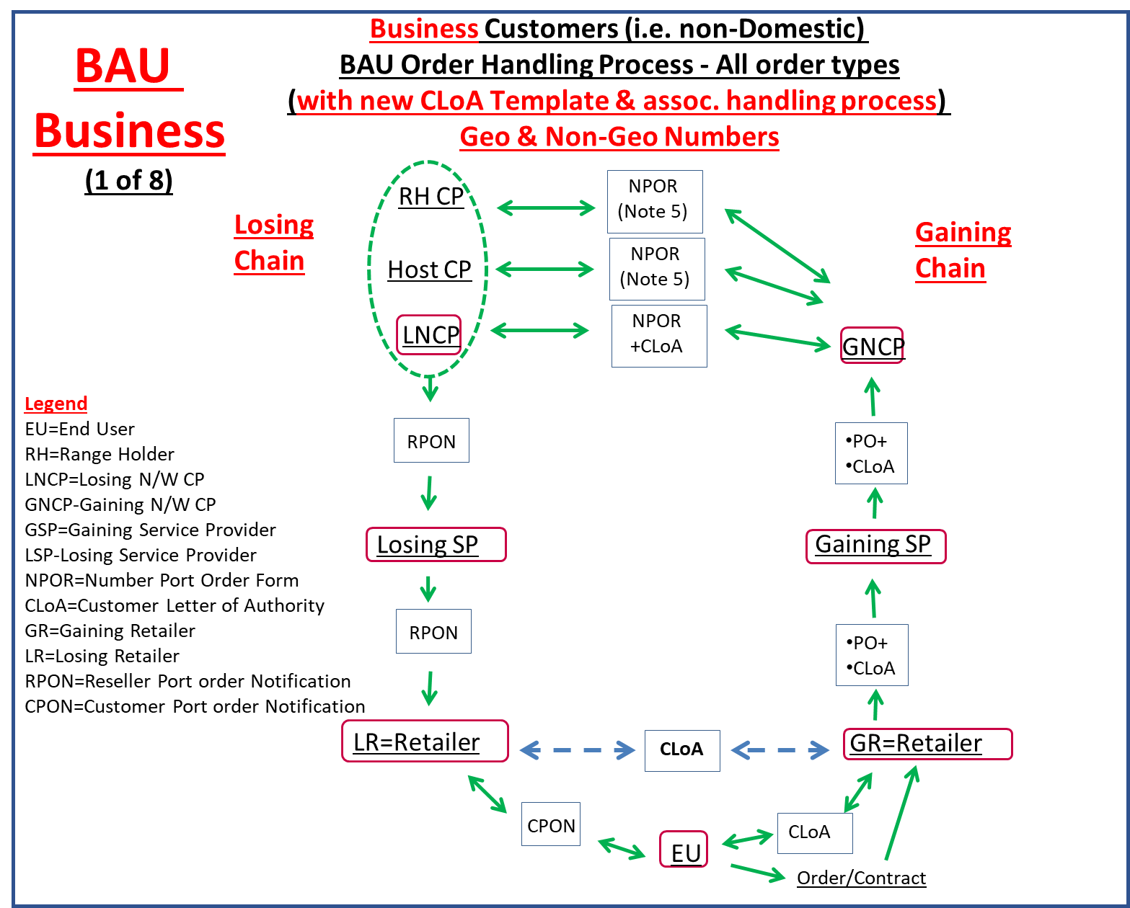

**Figure 1 – BAU (Business-as-usual) Order Handling Process**

## Geo & non-Geo process mis-alignment

A major source of CP confusion (and End User frustration) has existed due to the fact that the CLoA handling processes for Geo & non-Geo port orders are materially different. This means CPs need to re-adjust their order handling practices depending on whether the number to be ported is a Geo or non-Geo number.

Additionally, the CLoA handling process for non-Geo places a significant burden on the Gaining Party to ‘collect’ individual ‘LoAs’ from each reseller in the losing supply chain before they can submit the port order to their Wholesale partner (GNCP). This LoA ‘collection’ process can take forever and invariably leads to protracted delays and customer disappointment. In the worst case, customers sometimes lose faith & abort their request to port.

## A Single CLoA & order handling process (App. R1)

A single CLoA & order handling process for both Geo & non-Geo port orders is being introduced and will be modelled around the process previously used for porting Geo numbers.

The attached App. R1 (BAU & PoV Process schematics) provides a detailed description of the new BAU ‘business-as-usual’ order handling process and includes an updated CLoA template (App R2), tailored to the new/aligned process.

## Process description

### GR obtains signed CLoA from EU (New CLoA Template refers)

### GR submits Port order to GSP (inc. CLoA ). GR retains CLoA on file.

### GSP submits PO to GNCP (inc. CLoA if required)

### GNCP completes NPOR (including End User details derived from the CLoA) and sends to LNCP (inc. copy of CLoA if requested)

### Order Validation – Why? -

### The primary objective is to confirm that the End User placing the port order is the End User who currently ‘owns’ the number(s) concerned and therefore ‘owns’ the right to initiate the port order.

### Order Validation – How?

### Stage 1 - On receipt of the NPOR (inc. CLoA), the LNCP will check internal records to confirm that the number(s) concerned exist on their Network and, if so, identify which Reseller those numbers are currently assigned to.

### Stage 2 - Once this is confirmed, the LNCP will send a notification (inc. order details) to their Reseller partner affording them a time limited opportunity (<48hrs) to validate the End User details contained in the notification, against the corresponding End User details contained in the Reseller’s own internal systems.

### End User details to be matched for successful validation

### Geo order – Number(s) to be ported, Installation address P/C or Billing address P/C

### Non-Geo order – Number(s) to be ported, Billing address P/C, Billing Account Ref.

### N.B. Where there is no Reseller involved (i.e. the LNCP is also the Retailer), the LNCP will complete End User validation by referencing their own internal End User records.

### N.B. Where there is an intermediate Reseller, they are responbile for passing the LNCP’s notification alert through to the current Retailer for their prompt attention.

End User cancellation

* 1. On receipt of the port notification (from LNCP), the Reseller will separately notify the End User that a port order has been received, affording them a time limited opportunity (i.e. < Port date minus 24hrs) to request a cancellation if they so decide.

It is vital to ensure the End User is informed asap as they may wish to cancel due to change of mind or no knowledge.(e.g. slamming attempt).

Port Order Notification (PON) process

To underpin the PON process, 2 email templates are to be used: -

* RPON (Reseller port order notification, App R3)
* CPON (Customer port order notification, App R3)

1. The LNCP will notify their Reseller partner using the RPON template
2. On receipt of the RPON, all Resellers in the supply chain have a collective duty to promptly relay the RPON down the supply chain asap to the Losing Retailer.

.

1. On receipt of the RPON, the Losing Retailer should directly send the CPON to the End User. (App. R3)

The objective of this notification process is to afford the EU’s retailer (and any intermediate resellers) a time-limited opportunity(<48hrs) to flag any concerns (to the LNCP Wholesaler) regarding the port order. (e.g. inaccurate or missing detail)

For non-Geo numbers only - If the LNCP requires additional time (i.e. >48hrs) to process the NPOR (e.g. delayed replies from reseller chain), the LNCP may ‘provisionally accept’ the NPOR and will have a further 5WD to formally accept/reject the NPOR.

## New CLoA Template (App. R2)

A new CLoA template (Customer Letter of Authorisation) has been introduced which is simpler for customers to complete and, for CP future reference, includes clearer guidance as to its purpose and ground rules for usage.

## Port Order lead times – Geo & non-Geo alignment

The new CLoA handling process represents no change for Geo orders but for non-Geo orders, the Losing Wholesaler (i.e. Losing N/W CP) needs an increased time allowance to notify their immediate supply chain reseller who also needs to pass the notification down the supply chain and ultimately to the End User.

To facilitate this, the min. lead-time and associated NPOR SLA for non-Geo orders has been extended to match the existing lead-time & SLA for Geo-M/L orders.

All other lead-times and SLAs remain unchanged.



**Figure 2 - Minimum Order Lead-times**

# Enhanced Cancellation process

The cancellation process has also been enhanced to ensure the End User receives a timely ‘advice of port’ notification from their current retailer and to provide the End User with sufficient opportunity to cancel their port order before the port activation is completed.

The enhanced cancellation process is described in App. R1

# PoV - Pre-Order Validation Process (App. R4)

The PoV process (launched 2017) supplements the BAU (business-as-usual) order handling process and is an optional ‘pre-order’ step which can be used by GPs in the event that the LP is unable/unwilling to provide the information required.

CPs need to be registered to use the PoV process.

App. R1 (BAU & PoV Process schematics) provides further detail (inc. swim lanes and guidance regarding the PoV registration process).

# Appendices

## App. R1 – BAU & PoV Order Handling Process Schematics

## App. R2 – New CLoA Template

## App. R3 - PON Email Templates

## App. R4 – PoV Process Description

## [App. R5 - PoV Process Templates](https://www.magrathea-telecom.co.uk/industry_porting/documents/App_J2-PoV_Process_Templates-v1.5.xlsx)

## [App. R6 - PoV_Process Consolidated Contacts Register](https://www.magrathea-telecom.co.uk/industry_porting/documents/App_J3-Consolidated_Contacts_Register-PoV_Process-v9.pdf)