**Porting for Business Customers**

**Process Description**

**Geo & Non-Geo Numbers**

**1st May 2020**

Table of Contents

1.0 Table of Figures 2

2.0 Document Control 2

3.0 Definitions 3

4.0 BAU (Business-as-usual) order handling process 4

4.1 Background 4

4.2 Geo & non-Geo process mis-alignment 5

4.3 A Single CLoA & order handling process (App. R1) 6

4.4 New CLoA Template (App. R2) 6

4.5 Port Order lead times – Geo & non-Geo alignment 6

5.0 Enhanced Cancellation process 7

6.0 PoV - Pre-Order Validation Process (App. R3) 7

7.0 Appendices 8

7.1 App. R1 – BAU & PoV Order Handling Process Schematics – v1.6 (draft) 8

7.2 App. R2 – New CLoA Template – v4 (draft) 8

7.3 App. R3 – PoV Process Description – v1.7 8

7.4 App. R4 - PoV Process Templates-v1.5 8

7.5 App. R5 - PoV_Process Consolidated Contacts Register - v9 8

# 

# Table of Figures

**Figure 1 – BAU (Business-as-usual) Order Handling Process** 4

**Figure 2 - Minimum Order Lead-times** 6

# Document Control

|  |  |  |
| --- | --- | --- |
| Version | Date | Detail |
|  |  |  |
|  |  |  |
|  |  |  |

# Definitions

|  |  |
| --- | --- |
| BAU | Business-as-usual |
| CLoA | CLoA=Customer Letter of Authority |
| EU | EU=End User |
| GNCP | GNCP-Gaining N/W CP |
| GP | GP=Gaining Party(Retailer) |
| GSP | GSP=Gaining Service Provider |
| LNCP | LNCP=Losing N/W CP |
| LoB | Line of Business |
| LP | LP=Losing Party(Retailer) |
| LSP | LSP-Losing Service Provider |
| NDA | Non Disclosure Agreement |
| NPOR | NPOR=Number Port Order Form |
| NPP&CG | Number Port Process & Commercial Group |
| PoV | Pre-order validation |
| RH | RH=Range Holder |
| STSYG | STSYG=Sorry to see you go |

# BAU (Business-as-usual) order handling process

## Background

Port orders for Business End Users can be challenging for various reasons: **-**

1. Order complexity and scale can vary (e.g. mixed single & multi-line, DDI, Geo & non-Geo)
2. Supply chain complexity due to multiple Reseller involvement
3. Manual processes with minimal automation
4. Large reseller community with varying degrees of process awareness and compliance
5. Different handling processes for Geo & non-Geo port orders.
6. Process poorly documented

The BAU process is undergoing various Improvements designed to address these weaknesses.

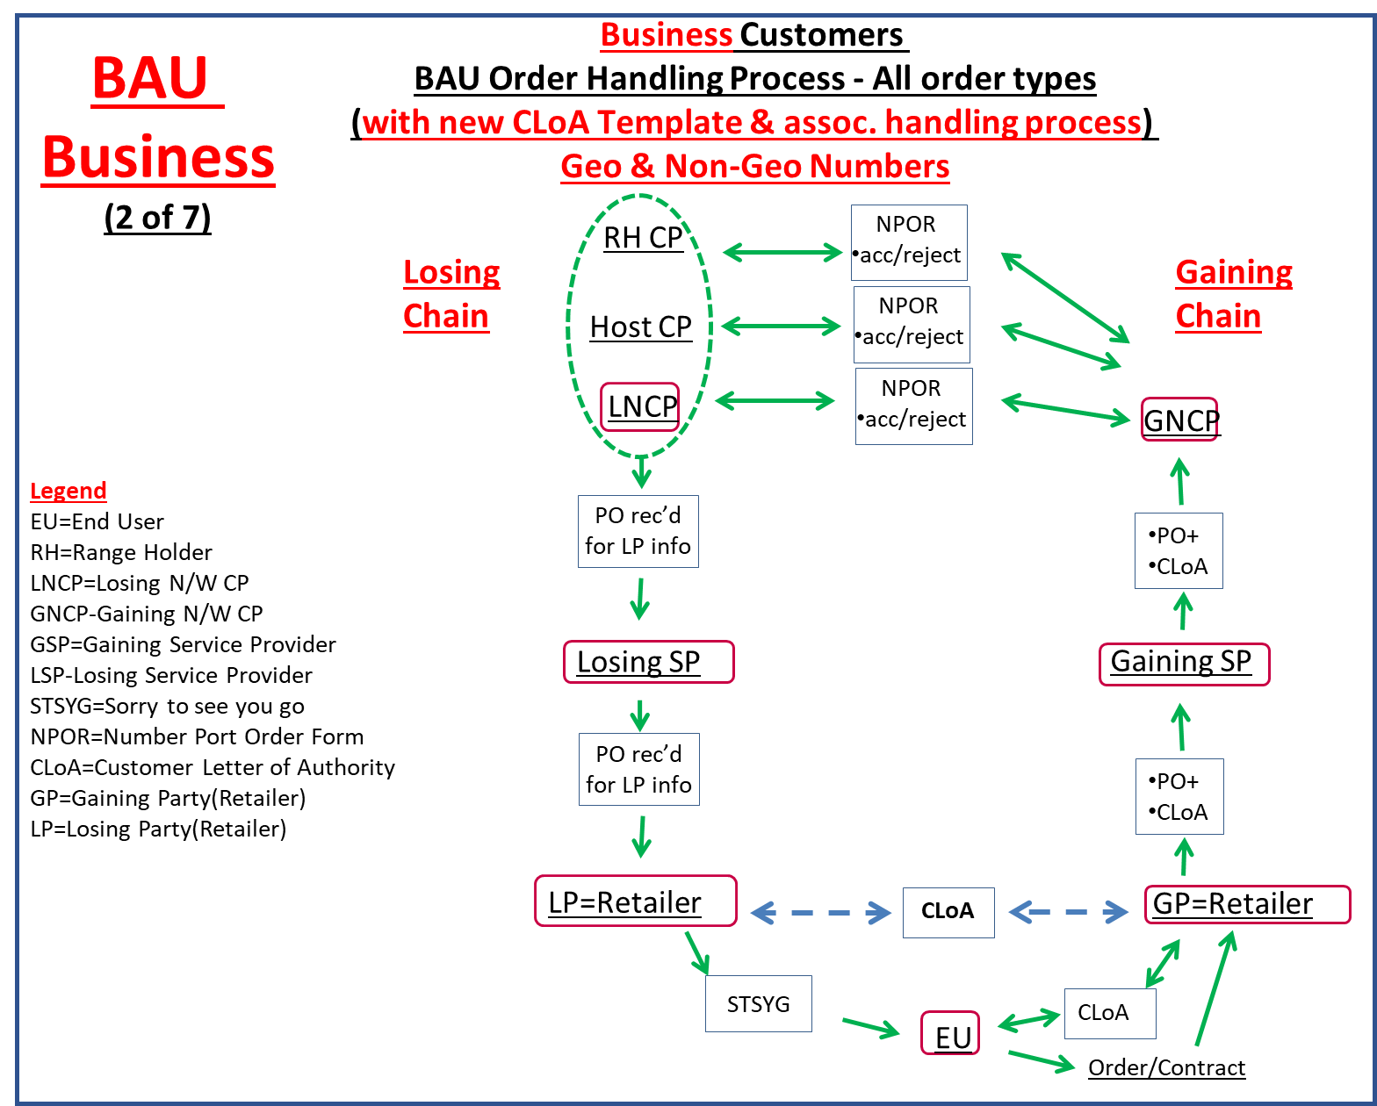

**Figure 1 – BAU (Business-as-usual) Order Handling Process**

## Geo & non-Geo process mis-alignment

A major source of CP confusion (and End User frustration) has existed due to the fact that the CLoA handling processes for Geo & non-Geo port orders are materially different. This means CPs need to re-adjust their order handling practices depending on whether the number to be ported is a Geo or non-Geo number.

Additionally, the CLoA handling process for non-Geo places a significant burden on the Gaining Party to ‘collect’ individual ‘LoAs’ from each reseller in the losing supply chain before they can submit the port order to their Wholesale partner (GNCP). This LoA ‘collection’ process can take forever and invariably leads to protracted delays and customer disappointment. In the worst case, customers sometimes lose faith & abort their request to port.

## A Single CLoA & order handling process (App. R1)

A single CLoA & order handling process for both Geo & non-Geo port orders is being introduced and will be modelled around the process previously used for porting Geo numbers.

The attached App. R1 (BAU & PoV Process schematics) provides a detailed description of the new BAU ‘business-as-usual’ order handling process and includes an updated CLoA template (App R2), tailored to the new/aligned process.

## New CLoA Template (App. R2)

A new CLoA template (Customer Letter of Authorisation) has been introduced which is simpler for customers to complete and, for CP future reference, includes clearer guidance as to its purpose and ground rules for usage.

## Port Order lead times – Geo & non-Geo alignment

The new CLoA handling process represents no change for Geo orders but for non-Geo orders, the Losing Wholesaler (i.e. Losing N/W CP) needs an increased time allowance to notify their immediate supply chain reseller who also needs to pass the notification down the supply chain and ultimately to the End User.

To facilitate this, the min. lead-time and associated NPOR SLA for non-Geo orders has been extended to match the existing lead-time & SLA for Geo-M/L orders.

All other lead-times and SLAs remain unchanged.



**Figure 2 - Minimum Order Lead-times**

# Enhanced Cancellation process

The cancellation process has also been enhanced to ensure the End User receives a timely ‘advice of port’ notification from their current retailer and to provide the End User with sufficient opportunity to cancel their port order before the port activation is completed.

The enhanced cancellation process is described in App. R1

# PoV - Pre-Order Validation Process (App. R3)

The PoV process (launched 2017) supplements the BAU (business-as-usual) order handling process and is an optional ‘pre-order’ step which can be used by GPs in the event that the LP is unable/unwilling to provide the information required.

CPs need to be registered to use the PoV process.

App. R1 (BAU & PoV Process schematics) provides further detail (inc. swim lanes and guidance regarding the PoV registration process).

# Appendices

## App. R1 – BAU & PoV Order Handling Process Schematics – v1.6 (draft)

## App. R2 – New CLoA Template – v4 (draft)

## App. R3 – PoV Process Description – v1.7

## [App. R4 - PoV Process Templates-v1.5](https://www.magrathea-telecom.co.uk/industry_porting/documents/App_J2-PoV_Process_Templates-v1.5.xlsx)

## [App. R5 - PoV_Process Consolidated Contacts Register - v9](https://www.magrathea-telecom.co.uk/industry_porting/documents/App_J3-Consolidated_Contacts_Register-PoV_Process-v9.pdf)